What Next? A response from Somewhere Cooperative Housing Association Ltd

Introduction

This short paper sets out SCHA’s response to the work undertaken for this Feasibility Study into connecting existing housing to the Bristol Heat Network.

At the outset SCHA was and still is an enthusiastic supporter of the development of the Bristol Heat Network. It is a bold development and should enable our city, the place where we live, to move towards a low carbon future. We say this despite having to live for the last few years in the middle of the construction of the network, with all its noise and disruption. We started with the simple question: Can we connect our houses to this network? After all the heat main is literally meters from the front doors of some of our houses.

We now understand it is not that simple. Technically and economically, the answer that has come back from the investigation we commissioned is more complex but still positive. We could connect, but we would need to work with others. Possibly the creation of a local community-owned heat network supplied by the Bristol Heat Network could be the way forward.

A financially viable option would be for connections to go through a local substation, which might serve a cluster of 50 to 100 homes or a group of end users in the same locality. As proposed in the main report, this might mean SCHA combining with other building owners to create a community-owned heat network in the immediate area. We imagine it might look something like this:

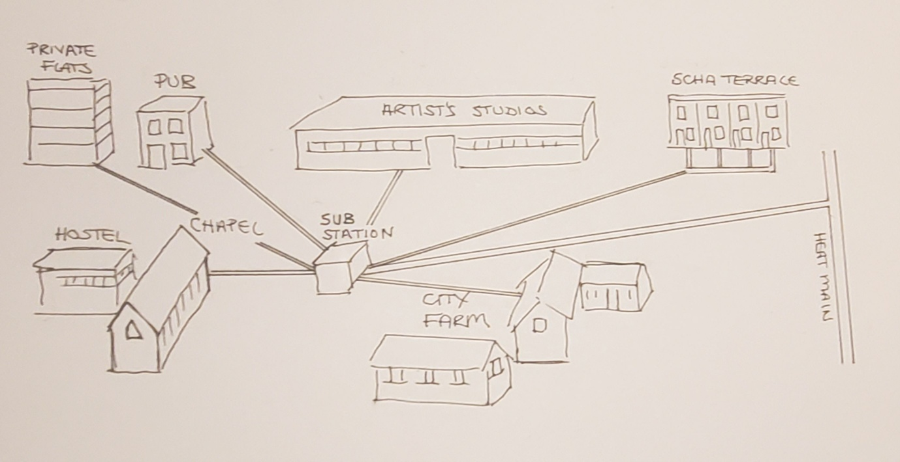
Community-owned heat network

So here we take that concept and ask: What Next? How might that happen? What needs to change? Who needs to take action? Here SCHA is drawing on:
- the conclusions of the final report of the feasibility study authored by Craig Spensley of Empowered Project,
- contacts with various players involved in creating the new regulatory and planning regime for District Heating Networks in the UK
- and discussions with members of the Supergen research hub that took place at the Supergen Heat Networks Annual Conference in September 2025, where SCHA made a presentation about this project

The social imperative: the need to ensure no-one is left behind
At the Supergen conference in September 2025, SCHA made a presentation where we laid out the case for connecting Victorian housing to district heating networks.
- Estimated 25% of population living in older pre-1919 existing housing (Historic England).
- 6 million houses built in Victorian era - many still standing and occupied, including many now as houses of multiple occupancy/flats.
- Pre-1919 housing having the highest rates of ‘non-decency’, nearly 1/3 failing to meet ‘Decent Homes Standard’ (English Housing Survey, 2023-24)
- Focus on older existing housing crucial to ‘leave no one behind’
This last point is very real for the members of SCHA in that we struggle to fund and implement measures to improve the energy efficiency of our Victorian houses (80% of our housing stock). In this we are not alone as there are literally thousands of Bristolians living in Victorian houses like ours. If it is to be ensured that no-one is left behind in the new era of district heating in Bristol, at least some of these Victorian houses need to be given access to the heat network as part of retrofit programmes.
The City Council has taken an area-based approach to its Warm Homes retrofit programme which is currently being rolled out in Henbury and Brentry, Avonmouth and Lawrence Weston. Bristol City Council should, where appropriate, include the offer of connection to the Bristol Heat Network as part of a package of energy efficiency improvements in future area-based retrofit programmes.

Regulation
In our presentation to the Supergen Conference we made the following observations about the new regulatory regime for heat networks:
- OFGEM is the new regulator of heat networks
- It is modelled on regulation of the competitive electricity and gas markets
- But heat networks are monopolies
- Good consumer protection is essential as customers can’t switch
- Effective price regulation is a must
- No current incentives for operators to connect their networks to existing housing
- No current incentives for householders or landlords of existing housing to seek connection
Indeed there appears to be almost no consideration of the issues involved in connecting existing housing (excluding blocks of flats) to heat networks. Action is required at a national level to ensure that the regulatory regime provides positive incentives for connecting existing housing.
Planning
The Energy Act 2023 states that heat network zones should be established across England and Wales in locations where a heat network would provide “the lowest carbon and lowest cost solution for heating and hot water”. Successful zone operators (in Bristol this is Vattenfall) will be granted exclusive rights to design, construct, operate and maintain district heating networks in the city or town, overseen by an independent Zone Coordinator. It is expected that local authorities will take on this role or appoint a Zone Coordinator. Zoning is currently being piloted in a number of areas, with one of the pilots being in Bristol. Zone Coordinators may well be given the key role of ensuring fair pricing of the heat supplied in their zone. The SCHA houses, assessed in our feasibility study, fall into the pilot Bristol zone.
There is no explicit commitment to connecting existing housing to district heating networks in any of these zones, including Bristol. But this will be vital in giving many Bristolians and most of SCHAs members access to “the lowest carbon and lowest cost solution for heating and hot water”. Vattenfall are quoted on the City Leap website’s Q&A as stating:
Are there plans and timelines to connect existing houses onto the network? Connecting existing homes is something the UK as a whole is still working on and the sector’s immediate focus is connecting new build buildings to the heat network. We are exploring pilot projects for connecting existing homes locally to demonstrate technical and economic viability.
Vattenfall has been very supportive of this project. It is understandable that they are currently focussed on connecting new developments to the Bristol Heat Network. They clearly need to establish a viable business. But looking to the future: Vattenfall should be taking on an enabling role, providing their technical expertise to local community-owned heat networks as they are developed. They should also be designing and constructing the heat network to facilitate multiple off-takes to serve local substations.

A replicable model

At the point when we were finalising the main report for this project, Andrew Faulks from Vattenfall sent us an email with the following summary of a project in Lancashire that he thought was very relevant to our main findings:

The Rossendale Net Zero Terrace Streets (NZTS) project offers a replicable model for community-led retrofit and shared heat infrastructure. It uses ambient ground loops and standing charge repayment, with no upfront cost to residents.

Implications for SCHA Based on NZTS Learnings
1. Scalability & Replicability:
NZTS demonstrates that street-by-street deployment with shared infrastructure can unlock economies of scale and funding.
SCHA could benefit from adopting a clustered retrofit and connection strategy, rather than isolated property upgrades.
2. Funding Strategy:
NZTS secured Innovate UK funding and aligned with multiple partners. SCHA may need to expand its coalition and apply for similar funding streams (e.g., GHNF, HNDU).
3. Community Engagement:
NZTS embedded peer-to-peer promotion and local champions. SCHA should consider early-stage engagement campaigns to build trust and participation.
4. Governance Model:
NZTS uses a Community Benefit Society structure. SCHA’s cooperative could explore similar legal frameworks to formalise ownership and access broader funding.

The infrastructure needed to connect existing buildings to the heat network – who pays?
In many instances will need substations which then connect to existing properties. Who pays for
Who takes the lead?
The Rossendale project is a very good blueprint for the way forward in Bristol and it supports the findings of our own report. Throughout this response to our findings we have highlighted in green text areas for action by various players that might support the next steps. Finally we come to our own role.
SCHA is a small cooperatively run housing association. It has just over 20 members and it employs a part-time administrator and maintenance coordinator. It relies on the voluntary contribution of its members to run the organisation. As such the capacity of SCHA to run big projects is very limited. For this reason the roles for SCHA suggested in the box describing the Rossendale blueprint are unrealistic. We now need to hand over the leadership of this initiative to a larger entity with professional staff. SCHA wants to be a partner/participant in future developments but we are not the right organisation to lead.
We completely support the proposal that a cooperatively based organisation should take the lead. This potentially would give end-users some real agency over the development and management of a community-owned heat network. But rather than reinvent the wheel we suggest that the Bristol Energy Coop should be approached as an existing entity with the appropriate range of capabilities to lead a full-scale pilot project.

Somewhere Cooperative Housing Association Ltd – November 2025

